Silicon Instuture of Technology, Bhubaneshwar
Date: 07.09.2020

A HYBRID MODEL OF VAWT TURBINE – SOLAR POWER GENERATION FOR HIGHWAY AND DOMESTIC APPLICATION

DHIRAJ KUMAR THAKUR, Regd. No.-1701209352
EEE,A1
Silicon Instuture of Technology

Abstract:
Now days the renewable energy sources are widely used over conventional energy source because renewable energy source are found abundantly in nature .Even in the present era the Renewable energy sources such as wind and solar has gain popularity and demand .But the concept of hybridization has impact a lot in overall increase in output power of these sources , which mean if used together then the overall efficiency is increased. These type of system also depend on the weather condition therefore if combine these two sources then we can produce desirable electrical power. This project design model of hybrid power generation system using wind-solar resources. This system can be implemented on highway dividers where due to the high speed motion of vehicles tremendous amount of wind energy can be collected and at the same time the solar energy from the sun will also be collected. Finally both energies will be collected simultaneously and using charge controller the batteries gets charged and is utilized for highway and domestic applications.

Keywords:
Vertical Axis Wind Turbine(VAWT), Photovoltaic, Hybrid charge controller, Pulse Width Modulation (PWM), Selector switch, Permanent Magnet Generator (PMG).

Introduction
Hybrid power are combinations between different technologies to produce power. Hybrid power plants often contain a renewable energy component (such as PV) that is balanced via a second form of generation or storage such as a diesel ,fuel cell or battery storage system .As in 21st century hybrid system has gain popularity. There are different types of hybrid power system for power generation such as Wind-Hydro system, Wind diesel system, Solar wind system,Solar hydro system etc. But in this particular model we have taken solar and wind as two component of hybrid system . Well there is a certain advantage for using hybrid power system because by using hybrid power system we can increase the overall output of the system .Since we are using Renewable Energy Source so it is eco-friendly in nature and also widely spread in nature

feature of vawt
There are generally two type of turbine Vertical axis wind turbine and Horizontal axis wind turbine. But for this model we are using Vertical axis wind turbine as because it has certain advantages over horizontal axis wind turbine. The best part of using this type of turbine is that it has great wind adaptability characteristics ,which means that no matter whatever be the direction of wind the rotor of the turbine will rotate. By using VAWT in this model we can easily install it in the highway divider area .In this project we will install this model in the highway divider where due to the velocity of wind generated by the the vehicles passing by will make the blades of VAWT to rotate

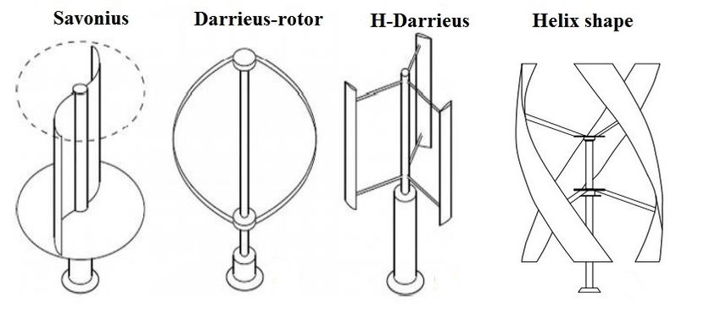
Fig 1

pv cell
Sun is the most abundant and absolute form of energy thatwe found in earth but to utilize this energy we use secondmost abundant element on earth that is sand.As silicon waffer is heart of PV cell so to make this waffer there is certain process which is explained briefly .Firstly sand is mixed with carbon and heated at 2000 degree to make raw silicon,then this silicon is converted to gaseous silicon which is mixed with hydrogen to make silicon waffer.The solar cell is mostly used nowdays.The output of solar cell is dc output. In this model i.e. hybrid model the solar panel is mounted on the top .

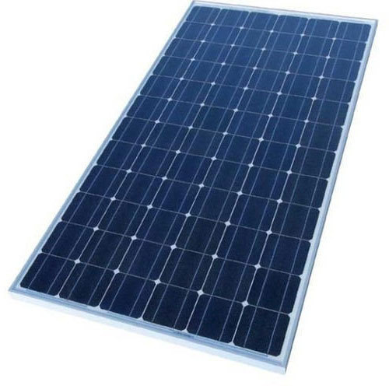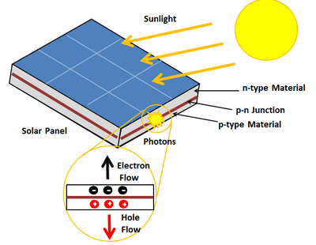

Fig 2

hybrid charge controller
The charge controller is electrical circuitry which monitor the wind and solar input voltage as well as battery voltage. The main function of the charge controller is to select suitable source either wind or solar to store the charge as well as to avoid the overcharging and discharging of battery unit .The solar charger can be of PWM (pulse width modulator) and MPPT (Maximum Power Point Tracking) .As nowadays every one uses MPPT type because it increases the overall output of system .It is 30 percent more efficient than PWM
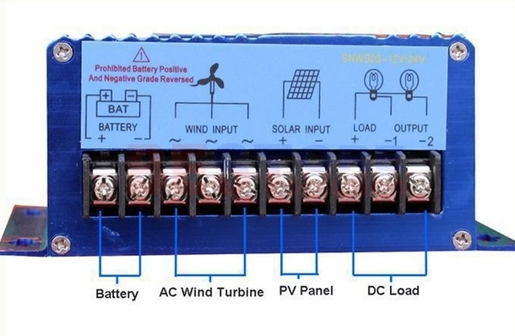
Fig 3

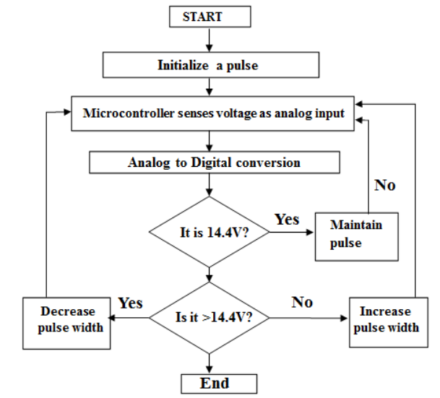

Fig 4

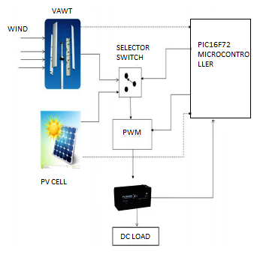
Fig 5
The block diagram of our model shows the overview of how it works to generate electricity effectively. Here electrical power generated by the respective systems is given to switching circuit. By comparing the battery voltage with both the inputs the controller gives signal to switching circuit to select appropriate input which used to charge the battery through pulse width modulation (PWM) controller,but instead of PWM we can use MPPT charge controller too.

Combined model
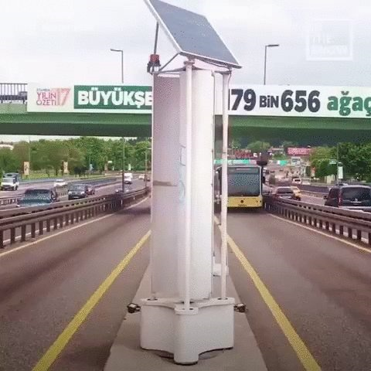

Fig 6

This is something that will be formed when we combine both solar and vertical axis wind turbine simultaneously .It doesn’t take much space so that the vehicle will not get any blockage while they are on road or highway. The power generated can be used for lighting purpose on highway. As this project is implemented on the divider of highway so the area that hybrid model covers should be within the width of divider which can be explained by the mathematical calculation given below

Mathematical calculation
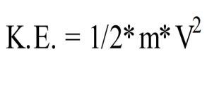
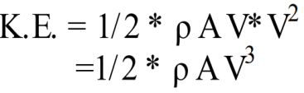
Since (m = ρAV)
Here, We want to produce 100 watt power for highway lights so, Pm = 100 watt Consider maximum wind velocity on highway is Velocity V = 8 m/s ,
Pm=1/2*ρ*A*V^3*Cp Pw = 1/2* ρ*A *V^3*Cp*η
So,
100 = 1/2*1.225*A *83 *0.35 *0.85 (For small turbine, CP=0.35)
i.e A=1.0718 sq.m
As the width of the divider is generally 1.5m so it can be easily installed.

what is enlil turbine ?
- ENLİL is a smart vertical axis wind turbine project that transforms highways into renewable energy sources by using the dynamics of the city.
- ENLIL generate energy by using the winds created by the vehicles as well as the natural winds and also by using sun (as solar panel is mounted on top of it).
- A single ENLIL turbine can provide the average daily electrical desires of two households.

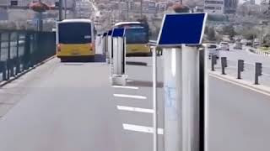
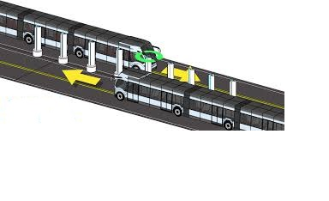 Fig:7
So this is the model which has been installed in Istanbul ,Turkey. This assembly has been installed upto 50 km in length.This also tells us about the environment temperature, CO2 level in air and many more .

application
- It has got several application if installed in right area.
- It can be also used in Railways where due to the velocity of train, the turbine gets rotated and power gets generated
- It can also be used in the high building apartment ,park ,household etc
- The village area where still the electricity is major issue even they can install it.

Result of the survey

wind speed in(meter/second) | turbine(rpm) | voltagegenerated(volt)
1.5 | 12 | 13.1
2 | 15 | 13.3
2.5 | 17 | 14.5
3 | 18 | 15.3
4 | 22 | 17.4
5 | 24 | 18.6

This is the stastistics or the result that have been analysed and collected after several experiments. In the experiment the gear ratio of 1:25 is used to achieve the rated 750 rpm of generator when turbine rotates at 30 rpm. To get the higher speed of 750 rpm 4 gear mechanism is used. According to test performed and the survey of wind generated on highway by moving vehicles, the operating time of wind turbine on average is 4 to 5 hours in a day at full rated output. The switching take place between solar and wind turbine according to voltage generated by them. Hence, the charging time required to charge the battery to full is reduced as compare to stand alone system.

CONCLUSION
Thus we can conclude that as today’s world is inclining towards the hybrid system this particular model has great role to play. As it has both of its component renewable so it will be more preferred over other system. It is eco friendly in nature and also pollution free and the best part is that it can be installed in the highway where it will utilize the dynamics of highway i.e wind generated by the vehicle passing by and converts into the usable energy. It can also be implemented at the railways area because the wind generated by train is more than the vehicle passing on the road. Finally, concluding that implementing this project can give electricity without pollution to many highways and small villages.

references

- Avinash P. Bavchakar, Ketan N. Chougale,Saloni S. Belanekar, Sushant P. Rane, Nitin B. Sawant, “A Hybrid Model of Vertical Axis Wind Turbine – Solar Power Generation for Highway and Domestic Application 2018 International Conference on Computation of Power, Energy, Information and Communication (ICCPEIC)

- P.Karthikeyan ,P.Dineshkumar ,R.Gokul, G.Tamilvanan “Design and Development of ENLIL Turbine For Highways Electrification. 2019 International Journal of Advanced Research in Electrical, Electronics and Instrumentation Engineering(IJAREEIE)

